**Classifying using DICHOTOMOUS keys**

When biologists go into the field to observe and classify plants or animals they often use a lassification key. Different defining characteristics are used to identify animals and plants in their appropriate groups at different levels of classification. Sometimes this can be a very complex task, so simple questions are used to separate organisms into groups, one question at a time. For example, you could separate humans into two groups with the question: are you male or female? If a key is made up of questions like this, with only two answers for each question, the system of classifying is called a dichotomous key.

A dichotomous key can be used to classify a larger group of organisms into individual categories. An example of a dichotomous key is given below. This key is used to separate members of a family (including pets), so each organism in the household can be allocated its correct name.

This method of having questions with only two answers can be written in different ways. One way is as a series of numbered questions – like the example on the left. Another way is to use the shape of a flowchart – like the example on the right. Notice the questions are the same in the table and the flowchart. Most people like the flowchart as it is easier to navigate, but when there are a large number of organisms the flowchart can take up too much room, and a table is the best method. The same key as the one on the left could be a flowchart like:



A dichotomous key can be written as a flowchart with two outcomes at every junction.

A dichotomous key can be written as a series of numbered questions like this.

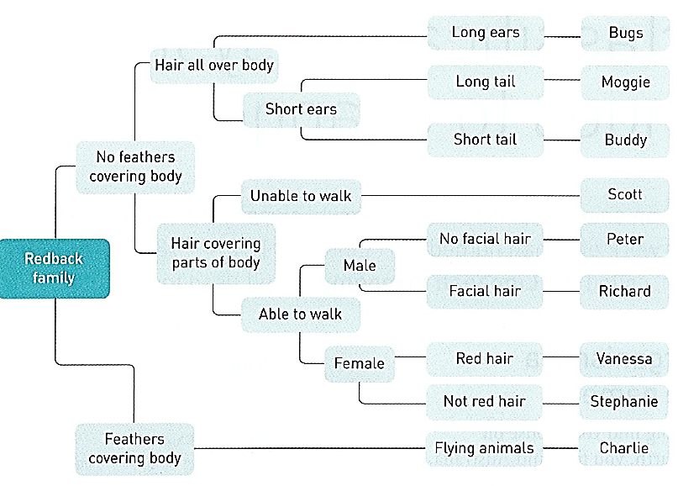

**Family** (including pets)

Dichotomous keys look very complicated, so you have to be methodical and follow the paths/questions of the key carefully. If you do this, they are a very useful way of separating a group of organism into individual categories.

Can you follow the key above? Answer the questions on the next page:

1. Is Charlie a pet or a human? Explain why you think this. (2)
2. List the names of the humans, and the pets in this family? (4)

Humans:

Pets:

1. How many organisms fit into the category of “having hair all over the body? (1)
2. Consider the two pictures below – name both family member. Beside each name, list all the features in the picture which allowed you to identify them. (2)
3. What is one key difference was used to separate Charlie and Stephanie into separate categories? (2)
4. What is the name of the human baby in the family? (1)